

FACULTY OF COMPUTING
SEMESTER 1 2025/2026

Assignment 3 : Academic Writing on Industry Talk 2

Title : Project Management dan System Development

COURSE CODE & SECTION : SECP1513-02
COURSE : TECHNOLOGY AND INFORMATION SYSTEM
LECTURER’S NAME : DR. ARYATI BINTI BAKRI
GROUP’S NAME : DATASYNERGY

 |  | 
NURAIN NABILAH BINTI AZMAN | LIM LI NING | NAJLA AUNI BINTI MOHAMAD ASRI
A25CS0324 | A25CS0249 | A25CS0117

INTRODUCTION OF THE SPEAKER
The speaker named Ts Abdul Alim Abdul Muttalib who is an experienced Information Technology (IT) professional with more than ten years of experience in the technology industry. He has worked in various roles such as software engineering, digital application development, AI product development, and IT management. Currently, he is involved in leading technology and innovation initiatives. His industry experience makes his sharing on project management and System Development Life Cycle (SDLC) relevant and practical for students.
PROJECT MANAGEMENT AND SYSTEM DEVELOPMENT
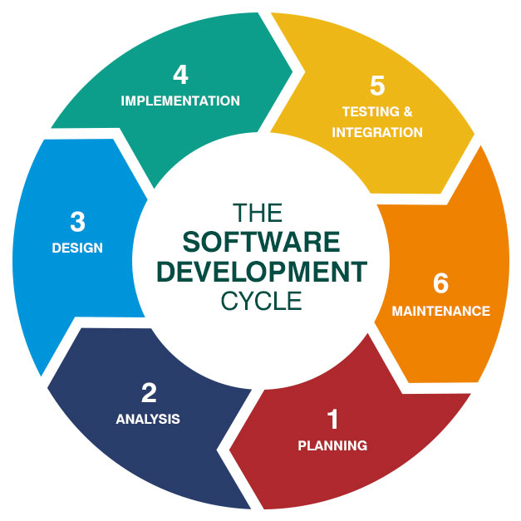
Project management is the application of knowledge, skills, tools, and techniques to project activities to meet project requirements. It is the practice of planning, organizing, and executing the tasks needed to turn a brilliant idea into a tangible product, service, or deliverable. System Development is not just writing code; however, it is the entire process of defining, designing, testing, and implementing a software application. Waterfall is a linear, sequential approach where each phase finishes before the next begin and it is one of the popular traditional SDLC Models. Beyond that, Agile is interactive approach where work is broken into small sprint also known as the modern SDLC Models. https://lvivity.com/sdlc-overview
APPLICATION IN DATA ENGINEERING
In Data Engineering, the System Development Life Cycle (SDLC) process is a must for building data pipelines that are both dependable and able to accommodate great traffic. Munappy et al. (2020) state that the management of data pipelines in real life needs a systematic method to cope with the difficulties of data flow, change, and storage. By adhering to SDLC phases, data engineers can help the data architecture to be the most efficient and that all changes to the pipeline are carefully tracked and recorded. In addition, Project Management (PM) plays a significant role in the maintenance and control of data quality. The deployment of PM in an effective way guarantees that data projects are not only concerned with the technical aspects of delivery but also with the accuracy and dependability of the produced data. Strong data governance and project oversight contribute to reducing data debt and improving consistency of information used for business intelligence across the organization.

REFERENCES
- Munappy, A., Bosch, J., Olsson, H. H., Arpteg, A., & Brinne, B. (2020). Data Pipeline Management in Practice: Challenges and Opportunities. 2020 46th academic paper. https://www.researchgate.net/publication/346632536
- Project Management Institute. (n.d.). What is project management. https://www.pmi.org/about/what-is-project-management
REFLECTION
LIM LI NING: In next four years, I will focus on building strong fundamentals in computer science and enhance my problem-solving skills by using SDLC instead of only focusing on how to code. I plan to practise regularly through assignment, small project and group work to gain more hands-on experience and broaden my horizons. Other than technical skills, I will improve my communication skills, teamwork and time management skills since those are not only essential in group project but future work. I will stay consistent and keeping learning so that I can feel more confident in preparing for a career in computer science.

NURAIN NABILAH BINTI AZMAN: What success looks like to me in this field for the next four year is I be able to master and evolving in skills I've learned throughout my degree such as teamworking, communication skill and problem-solving skills. First, I will focus on core Computer Science concept for instance data structures, algorithms and discrete math to enhance my understanding. I’ll complement this by building a professional e-portfolio on GitHub, cultivating a professional presence on LinkedIn and developing deep proficiency in a key language like C++. Next, I will engage with the community. I’ll join the computer science club and contribute to open-source projects. This will be crucial for building my network, teamworking skills and expanding reputation. Finally, to specialize and validate my skill in the real world, I will aggressively pursue internships and tailoring my project to show initiative and stand out.

NAJLA AUNI BINTI MOHAMAD ASRI: My primary target for the next four years is to success in Computer Science, and I will accomplish it through mastering the fundamental principles which are programming, problem-solving, and computational thinking. I will view SDLC as an actual professional practice and will carefully plan, design, and test the systems before the coding stage. For group projects, I will use an Agile method that will be mainly about collaboration, communication, and making feature prioritization the first thing to consider. Besides that, I want to shift my role from being merely a programmer to a system architect through AI and agentic coding, and at the same time, acquiring industry-relevant skills such as system design, and adaptability to remain updated with the tech world's changes.

